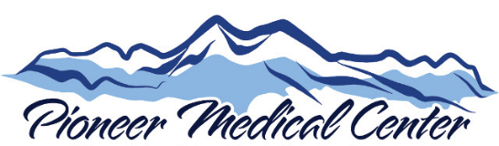
Your Health- Our Commitment
Board of Directors
Meeting Agenda
Thursday December 2nd, 2021
**= Action Item

Meeting will be held at the ambulance barn for social distancing purposes.

- Call to Order – 5:00 pm
- Consent Agenda
  - **November 4th; Approval of Board Minutes (Item #1)
  - Finance Report
    - October Financial Report (Item #2)
b) Memorial Fund (Item #3)
- Old Business
  - CEO Report- Ian Peterson
- New business
  - **Med Staff Bylaws
- Medical Staff Report- Dr. Walker
- Credentialing- Dr. Walker
  - Brandon “Brandi” Young, DNP
- Commissioner Report- Bill Wallace
- Director of Nursing Report- Diane King, RN
- Billings Clinic Update
- Public Comment Period
- Executive Session
- Upcoming Dates
  - Next Board Meeting- Thursday, January 6th, 2021 5pm
- Adjourn

