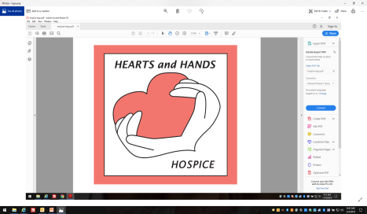

2025 Hearts & Hands Hospice
SCHOLARSHIP

Hearts & Hands Hospice is pleased to announce plans to present two $750 scholarships in 2025. One scholarship will be presented to a high school student planning to enter the healthcare field and one scholarship will be presented to an individual already attending college and majoring in a healthcare field.

The scholarship award is intended for educational use billed by the college or university (i.e., tuition, fees, books, on-campus room, and board). The award check is mailed directly to the winner’s school upon written verification of enrollment. It is the responsibility of the winner to present the verification to the Treasurer of HHH by September 1, 2025 before any money will be paid out.

The award money must be used within the next academic year.

Children of any HHH Board member are not eligible for a scholarship in the year that individual serves.

QUALIFICATIONS FOR APPLICANTS

1. Be a resident of Sweet Grass County

2. Plan to declare a major in the health-care field (or have already done so)

REQUIREMENTS FOR APPLICANTS

1. Must have an overall 2.5 GPA, based on a 4.0 Scale

2. Must be a graduating high school senior or a student currently enrolled in a junior college, 4 year college or university

3. Must have demonstrated scholarship, leadership, and outstanding performance

2025 APPLICATION
Hearts & Hands –Scholarship

Part A
To be filled out by the applicant. This application must be signed to indicate that the information is current and complete. Please print information. If more space is needed to complete any items, use blank paper and indicate item number.

Name___________________________________________________________________

Address__________________________________________________________________

Phone_______________________________

Date of Birth__________________________ Sex______________

Name of Parents or Guardian (if applicable) ______________________________________

1. Name of college or university in which you are currently enrolled or plan to enroll:

2. List your major field of study:

3. Honors & Awards (scholastic and community) that you have received:

4. Church, Community, and Service Organization Activities:

5. Employment History (Last 3 years):

IT IS UNDERSTOOD THAT:

1. This award will be based primarily on scholastic achievement, citizenship, and overall performance. Financial need will not be considered.

2. I am currently a student at a college or university and plan to continue enrollment during the next academic year, or I plan to enroll as a new student for the next academic year.

APPLICANT’S SIGNATURE: __________________________________________________________

PART B

To be provided by applicant: OFFICIAL TRANSCRIPT to include current GPA.

Part C

Please provide an essay of not more than 250 words explaining your chosen field of study, how you hope to contribute to the health-care field, and why you need this scholarship.

Part D

Please provide two letters of recommendation from an adult (non-family member) stating why this applicant is deserving of this scholarship award.

PLEASE SEND THE COMPLETED APPLICATION (Parts A, B, C, D)
by April 1st, 2025 to:
Hearts & Hands Hospice Scholarship
PO Box 1337
Big Timber, MT 59011

